Case 3-ME-Syro-Hittite-Triple-Headed Astarte Figure, Terra Cotta-2800 – 1500 BCE 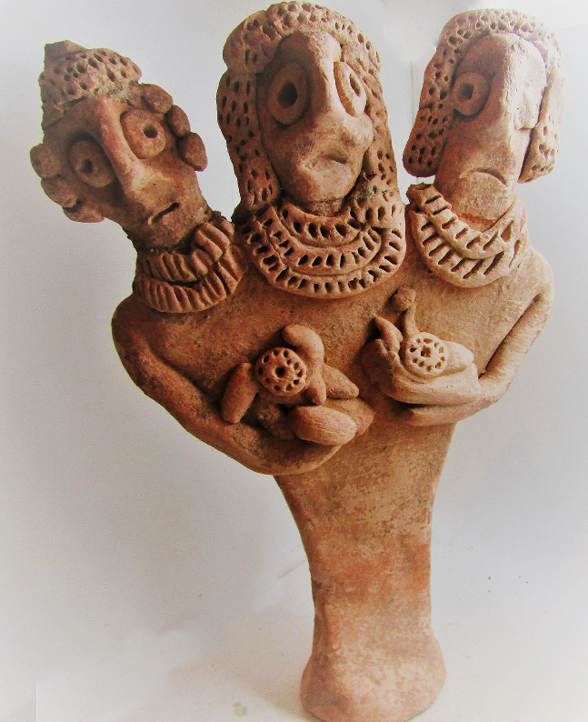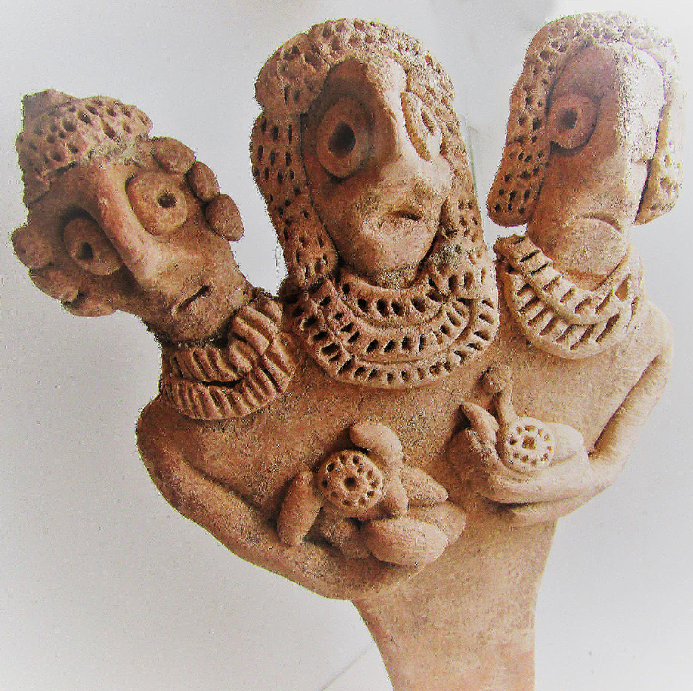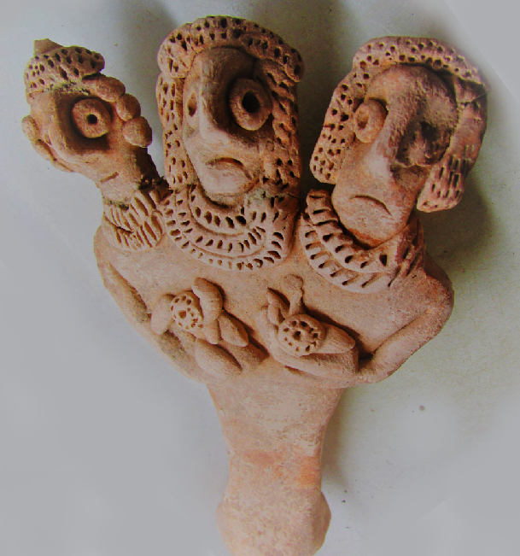

ME-Syro-Hittite-Triple-Headed Astarte Figure, Terra Cotta- 2800 – 1500 BCE

**Display Description:**

**Case no.: 3**

**Accession Number:**

**Formal Label:** ME-Syro-Hittite Triple-Headed Astarte Figure, Terra Cotta- 2800 – 1500 BCE

**Display Description:** This Syro-Hittite Triple-Headed Astoreth Figure probably represents a trinity of different aspects of Astoreth ([Northwest Semitic](https://en.wikipedia.org/wiki/Northwest_Semitic_languages)), a form of [Ishtar](https://en.wikipedia.org/wiki/Ishtar) ([East Semitic](https://en.wikipedia.org/wiki/East_Semitic_languages)), who was worshipped from the [Bronze Age](https://en.wikipedia.org/wiki/Bronze_Age) through [classical antiquity](https://en.wikipedia.org/wiki/Classical_antiquity). The name is particularly associated with her worship in the ancient [Levant](https://en.wikipedia.org/wiki/Levant) among the [Canaanites](https://en.wikipedia.org/wiki/Canaanite_religion) and [Phoenicians](https://en.wikipedia.org/wiki/Phoenician_religion). She was also celebrated in [Egypt](https://en.wikipedia.org/wiki/Ancient_Egyptian_religion) following the importation of Levantine cults there. The name Astarte is sometimes also applied to her cults in [Mesopotamian](https://en.wikipedia.org/wiki/Mesopotamian_religion) cultures like [Assyria](https://en.wikipedia.org/wiki/Assyrian_religion) and [Babylonia](https://en.wikipedia.org/wiki/Babylonian_religion).

This rare example shows the central figure as being the most prominent with three strands of beads in her necklace while the flanking deities only have two strands. The hair styles on all three are distinguished with the central figure having a tiara-like bouffant hair style, and the figure to her left having a plainer bouffant and the figure to her right having a cap-like hair-do. The two arms for all three are rudimentary and are tucked under centrally placed breasts covered by floral designs.

The main body tapers to a rounded, concave disc, with a simple physical form until it reaches the arms and shoulders. The design of the eyes relates to the common motif throughout the Ancient Near East that eyes must be wide and attentive to show religious devotion.

**LC Classification:**

**Date or Time Horizon:** 2800 – 1500 BCE

**Geographical Area:**

**Map:**

**GPS coordinates:**

**Cultural Affiliation:**

**Media:**

**Dimensions:**

**Weight:**

**Condition:**

**Provenance:**

**Discussion:**

**References:**